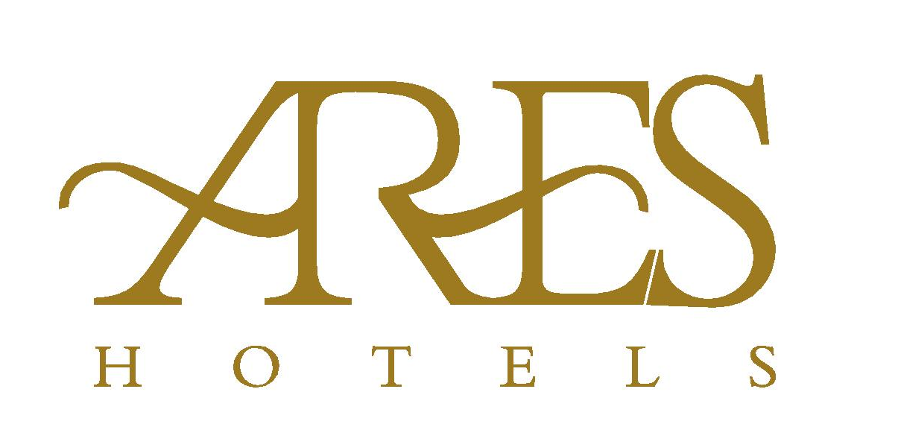

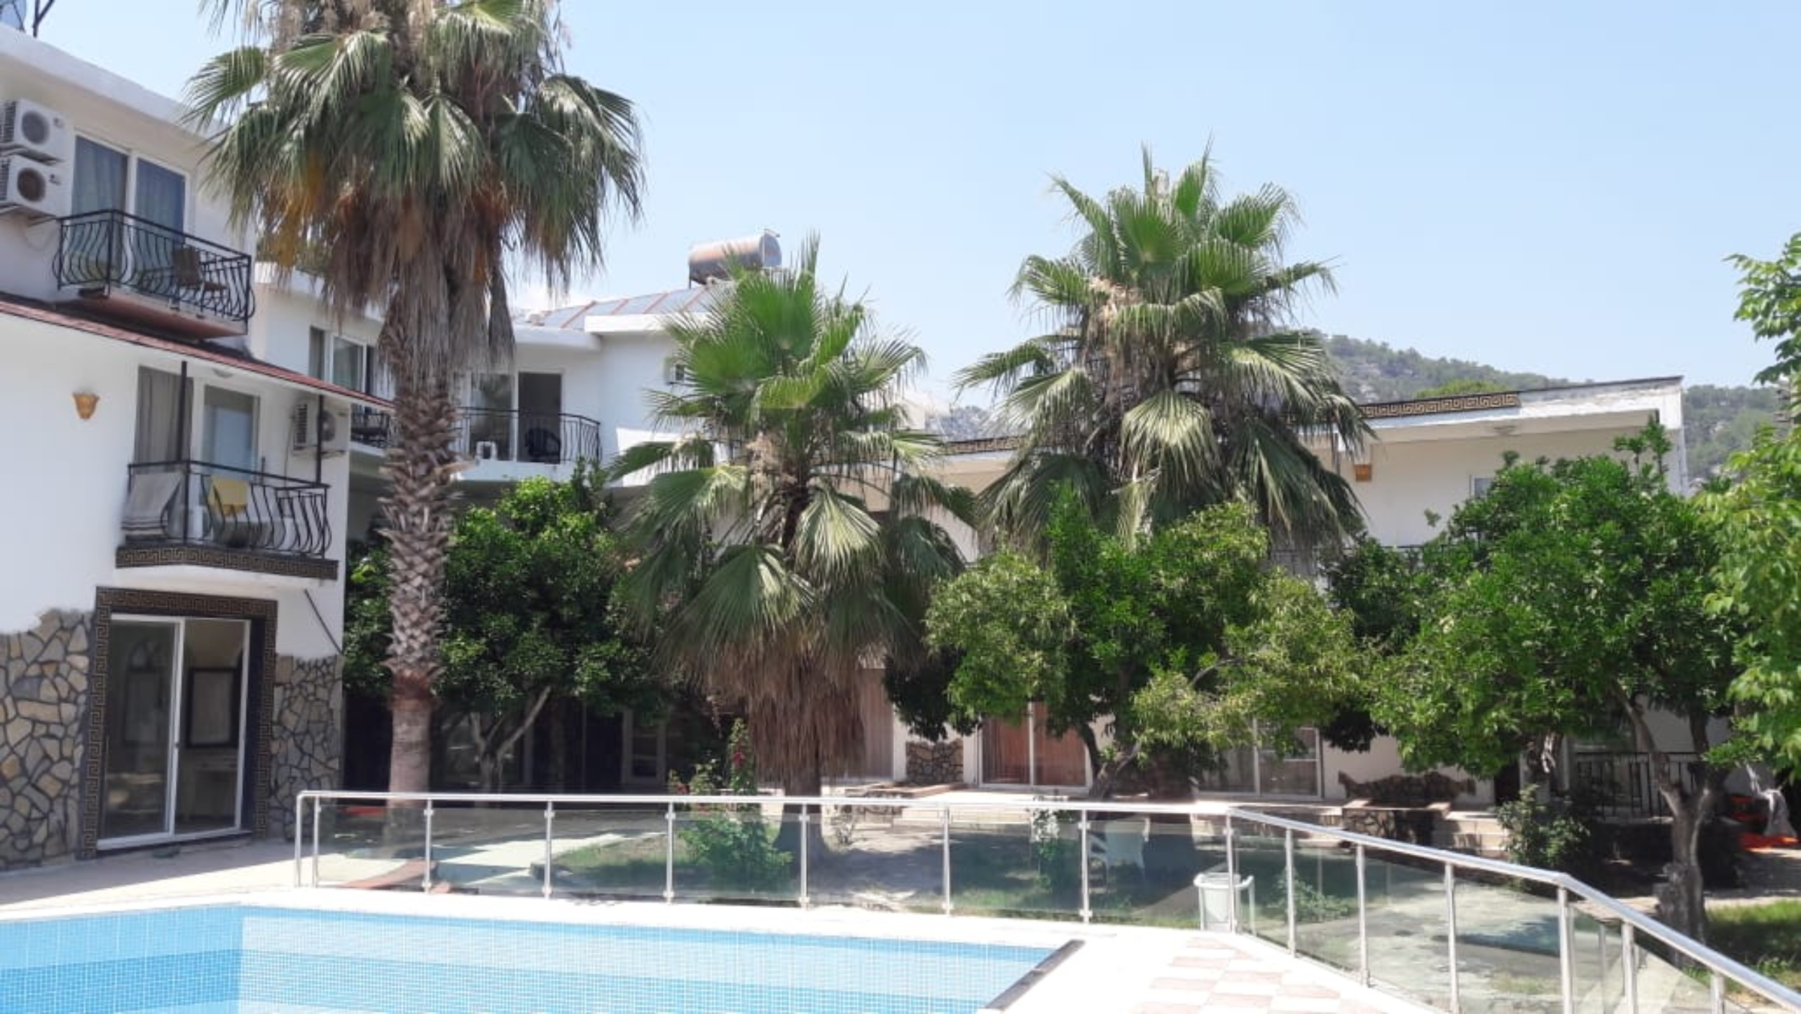
Adres : ARES ENDAM GARDEN HOTEL
Beldibi Mahallesi 4014 sokak No:17
Beldibi /Kemer / Antalya
Tel. : +90.242.606 12 90
Mail : reservation@areshotels.com.tr

ARES ENDAM GARDEN HOTEL
CONCEPT

Check-in time at 14:00 and Check-out time at 12.00 o’clock.
RESTAURANT | OPENING | CLOSING
Breakfast | 07:30 | 09:30
Lunch | 12:30 | 14:00
Dinner | 19:30 | 21:30
Coffee Break | 17:00 | 17:30

Pool | 09:00 | 18:00
Slide | 10:00 | 12:00
Slide | 14:00 | 16:00
Bar | 10:00 | 22:00

ALL INCLUSIVE SERVICES

ARES ENDAM GARDEN HOTEL guests, can use all of the qualities of ARES ENDAM BEACH HOTEL except rooms and alcoholic beverages.

- Offered meals in the buffet (breakfast, lunch and the dinner)
- Coffee break services (cookies and cake)
- Soft drinks (to 22.00 o’clock)
- Tea, coffee and concentrated fruit juice.(to 22.00 o’clock)
- Local wine (to 22.00 o’clock)
- All drinks will serve with plastic, paper cup at the pool bar and the beach.
- Hamam and sauna are free for self-using at the specific times.
- 100m2 outside pool (including child pool) and 1 water slide
- Beach towels are free and can be taken from Hamam
- Free public beach, sunbed and umbrella are priced for 15TL per person.
- Domestic Animals are not allowed.

PRICED SERVICES
- Safe box (2€/per day)
- Wi-Fi (Price information at reception)
- All alcoholic and non-alcohol drinks
- Doctor/Nurse
- Hamam

